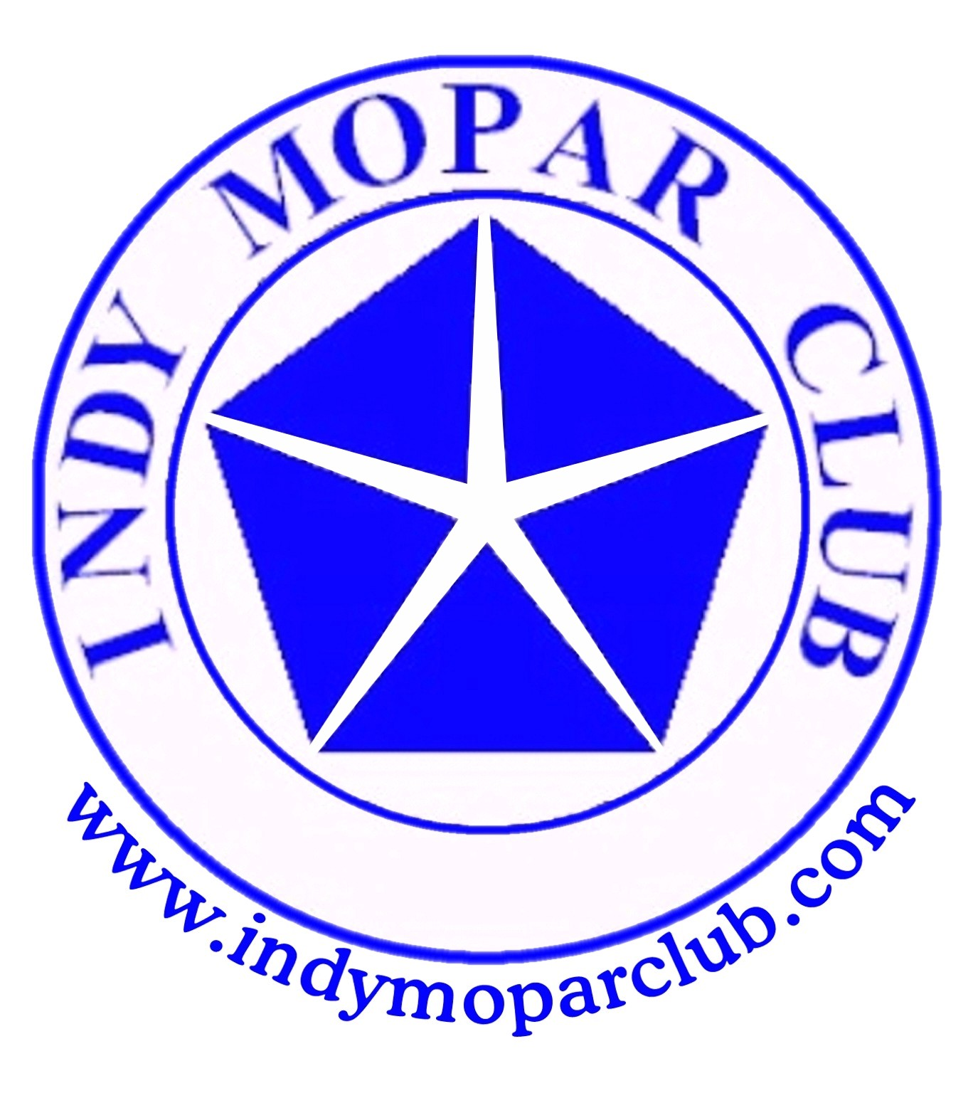 Indy Mopar Club News
March 2008 www.indymoparclub.com Jan Peel and Dave Watt, editors
Meetings are the last Thursday of every month

Next regular meeting: Thursday March 27, 2008 will be held at MCL Cafeteria, 3630 South East street Indianapolis (US 31- N of Southern Plaza between Sumner & National). Meet for dinner at 6pm, meeting at 7pm.

2008 schedule of events. More events and details on the way.

April 24, 2008 regular meeting location will be at Indy Powder Coating for a 7 pm demonstration.
1201 Main Street, Speedway, IN. 46224 (317)-244-2231. Please have your meal before the meeting.
May 3, 2008 the Indy Mopar Club will host an all Mopar Car Show at Palmer Chrysler Jeep Dodge NEW LOCATION, 5051 West Pike Plaza Road. (317)-293-4900. Registration 9-noon, awards at 3pm. Top 20, Presidents Choice, and The Finer Details awards. Event T-shirt and goody bag to the first 40 entries. Door prizes, 50/50 drawing, food, DJ are some of the events planned. Rain date May 10.

May 17, 2008 the Indy Mopar Club will host an Open Car Show at Fletcher Used Cars in Edinburgh. Registration 9-noon, awards at 3pm. Door prizes, 50/50 drawing, food, and DJ are some of the activities for the day.

June 21, 2008 the Indy Mopar Club will host an all Mopar Car Show at Fletcher Chrysler Dodge Jeep, 3099 S. Morton Street (US 31 South), Franklin Indiana. Registration 9-noon, awards at 3pm. Top 20, Presidents Choice, and The Finer Details awards. Event T-shirt and goody bag to the first 40 entries. Door prizes, 50/50 drawing, food, and DJ are some of the events planned. Rain or shine.

September 20, 2008 the Indy Mopar Club will host an all Mopar Car Show at Danville Chrysler Dodge Jeep. See website Upcoming Events page for new dealership location. Registration 9-noon, awards at 3pm. Top 20, Presidents Choice, and The Finer Details awards. Event T-shirt and goody bag to the first 40 entries. Door prizes, 50/50 drawing, food, and DJ are some of the events planned. Rain date September 27.
Read about Bob’s Challenger convertible on page 2.
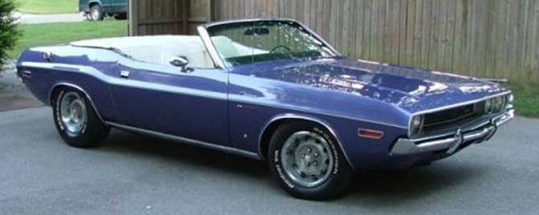
Hello, my name is Bob Schonegg. I have a wife named Julia, a son who has graduated from Depauw named Christipher, a son who is a senior at Center grove High school and on his way to I.U., and a daughter named Cindy who is in the 6th grade at Center Grove.

I grew up in a Ford family. My dad had Mustangs, Mavericks, Torinos and Country Squire station wagons, but in 1974 my older sister bought a used car. It was a triple green 1968 Plymouth Satellite. She drove this car for 2 years when she decided to sell. I had just turned 16, and she sold the car to me. The car was in great shape but it was a 318 auto with bench seat and triple green. Not much in the way of cool or so I thought at the time.

While driving home one day I spotted this yellow Challenger for sale, I quickly did a turn around and pulled up behind this car. I knew right then that this car had a lot of cool factor. It was Canary yellow exterior, black interior, pistol grip shifted four speed, bucket seats, dual Hush Thrush exhaust with headers. Cragar SS wheels with air shocks and a CB radio with whip antennae on the trunk. Talk about cool factor, (this was 1976 remember).

That is how I got my start in Challengers. I have never been without one since. I have owned 7 Challengers in all, 2 of them just parts cars. I sold my ‘71 and bought a ‘70 340 four speed purple Challenger for $400. I then bought my ‘71 Pace car and parted out the four speed car. The pace car Challenger was my everyday car until 1982.

Then while driving on the south side of Indy on 465 I spotted my current car sitting in a used car lot. I traded my Pace car for the current Challenger. This then became my everyday car until I got married in 1987. My wife and I had our first date in this car. I started the restoration in 2002 and still do not have it 100% done. I don’t think that you ever have them done.
Thanks for your interest, Bob
<><><><><><><><><><><><><><><><><><>

Welcome to new members:
Clark & Chris Bonebrake, Fishers, 1974 Dodge Challenger and 1965 Plymouth Barracuda
James & Laura Bratby, 1973 Valiant Charger 770
Scott & Shari Herring, Lebanon, 1973 Plymouth Barracuda
David Opel, New Palestine, 1966 Plymouth Belvedere II and 2002 Dodge Dakota
Gary & Kim Rogers, Greenfield, 1967 Chrysler New Yorker
Kenneth Schoemer, Brownsburg, 1970 Plymouth Fury III and 1965 Plymouth Sport Fury.
We hope to see all of you soon at a meeting or upcoming event.
<><><><><><><><><><><><><><><><><><>

Our sincere condolences and sympathy go out to Cheryl and Steve Wisdom. Cheryl’s mother, Stella Carter, passed away February 29th.
<><><><><><><><><><><><><><><><><><>

INDY MOPAR CLUB Monthly Meeting Secretary Report February 29, 2008 7:00 PM

Welcome and sign in – Steve Wisdom, President:
Steve Wisdom brought the meeting to order at 7:00 PM. Steve asked all members and guests to introduce themselves and be sure to sign the attendance sheet.

Secretary’s Report – Ronda Cherry:
Ronda read the highlights of the January 2008 meeting.

Treasurer’s Report/Membership Update – Mike Leyes:
Mike gave the treasurers report as of February 28, 2008. January 31, 2008 Balance was $1,807.81;
Income for February was 21 membership dues of $630.00, additional 08 member shirts $20.00, deposit
January change $100.00
Expenses – Reimbursement for January meeting food, 134.10, reimbursement for photo processing
$26.39, paid to Utters for 2008 member shirts $1,110.88.
Balance February 28, 2008 is $1,286.44.
We currently have 45 members in the club.

Event Calendar – John Bauer:
Dave talked about upcoming events for the year:
May 3rd Palmer Dodge-Indy Mopar Club all Mopar Car Show – Rain date May 10th

May 17th Edinburgh Open Car Show
June 21st Fletcher Chrysler-Indy Mopar Club all Mopar Car Show
September 20th Danville Chrysler- Indy Mopar Club all Mopar Car Show – Rain date September 27th

Event Advertising – Pat & Pat McKarski:
Pat gave an update on the advertising. They are presently advertising in
Indy Auto & RV
Old Cars Only
Mopar Collector’s Guide.
Pat has also been in touch with 101.9 radio station, Wish TV and WTHR TV in Indianapolis to advertise our shows and possibly have coverage the day of the event.

Communications Director Report – Dave Watt:
Dave is sending the newsletter to all members that have E-mail with the balance being mailed by Jan.
He is putting a message page on the website. Dave is also in touch with Cart Art signs for door prizes or items that can be used as “Goodie Bag” fillers.
Dave will print the pictures to make up a new Photo Album to be displayed at car shows. We do need new albums. Members were asked to be on the lookout for inexpensive Photo Albums.

Old Business – Steve Wisdom:
- Club Member Profile for Newsletter & Website
  - March – Bob Schonegg
  - April – Rick Eilert
  - May – Larry Mayes
  - June – Dick & Dorinda Crawmer

- Joint get together with another Mopar club.
Tri State Mopar Club: Eric Gegert (513) 892-2042 kagebert@fuse.net River Valley Mopar Club, maybe August 23rd.
1. Cruise-in or Cruise-in and Park picnic

- Palmer Dodge 2008 show date confirmed for May 3rd, rain date 10th, at new location
Edinburgh Open show date confirmed for May 17th, with participant voting to determine winners.
Fletcher Chrysler show date confirmed for June 21st
Danville Chrysler show date confirmed for September 20th, rain date 27th, in new location

- IMC Name Tags (Renewals for 2008) – Larry Mayes brought tentative clip-on name tags as a donation to the club. Larry displayed samples of optional name tags and corresponding prices. A discussion followed, the membership will decide next month on this issue.

- Swap Meet in March 2008
  - Sign-up Sheet for volunteers was passed around
  - Set-up day – February 29 noon to 8pm. Set up time will be 1pm.

- Flyers for all shows were passed around. Thanks to Rose Richard for creating them and Heron Printing Company for printing them.
Club Applications were passed around. Thanks to Diane Biesel for creating them, and thanks to Bob Biesel for printing 250 of them.

- Mecum Auction would like 20-25 club members to help with the auction. We need more volunteers.

New Business – Steve Wisdom:
- Car Show Door Prizes – Steve created 3 notebooks he made for volunteers to take with them to solicit door prizes and “Goodie Bag” items for the Car Shows. They have a letter from the Juvenile Diabetic Research Foundation showing their appreciation for our donations and flyers for all the upcoming shows.
  - Palmer Show – Pat McKarski, John Bauer, and Mark Smith
  - Fletcher Edinburgh Show – Steve Wisdom and Rick Zimmerman
  - Fletcher Franklin Show – Steve Wisdom and Rick and Ginger Zimmerman
  - Danville Show – Tom Kelly & ?

- Club meeting location – a vote was taken and for March we will again meet at the MCL Cafeteria, 3630 South East St. Come early at 6pm and eat before our meeting at 7pm.

- April meeting will be at Indy Powder Coating. Information will be in the upcoming newsletter.

- Discussion about photo shooting at the car shows. Dave Watt said Dave Stephenson is the primary photographer with Dave Watt as back-up.

- A discussion then took place regarding new member T-shirts every year. More discussion to follow at an upcoming meeting.

Steve Wisdom then adjourned the meeting.

Respectfully submitted – Ronda Cherry, Secretary
<><><><><><><><><><><><><><><><><><>
April Birthdays: Bob Beisel, 4-2; Diane Gillock, 4-4; Debbie Komlanc, 4-5; Ginger Zimmerman, 4-14; Rick Eilert, 4-15; Rick Zimmerman, 4-19; Stan Peel, 4-27; and Verne Williams, 4-27. Congratulations to all!
April Anniversaries: I am not showing any anniversaries for April.
<><><><><><><><><><><><><><><><><><>

Information
New information for Rick & Ginger’s son Ryan who is stationed in Iraq:
Pfc Ryan Johnson
1-75 CAV, 2 BCT, 101 ABN
Unit # 43488
APO AE 09344
His E-mail address is now: airborneu173@aim.com

