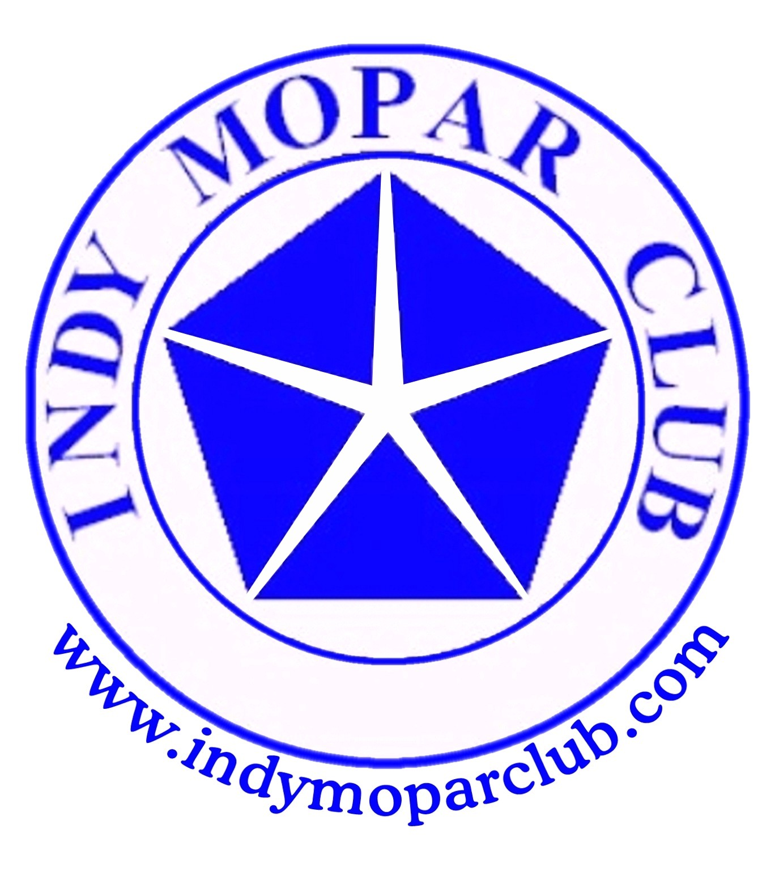 Indy Mopar Club News
March 2007 w ww.indymoparclub.com Dave Watt and Jan Peel, editors

Meetings are held the last Thursday of every month except December due to the holidays.
More dates and times will be added soon.
Happy 8th anniversary to the Indy Mopar Club. The first meeting was held in March 1999.

On March 3 and 4, 2007, the Indy Mopar Club set up a club display at the 12th Annual Chrysler Performance Trade Show & Swap Meet hosted by Indy Cylinder Heads held at the Indiana State Fairgrounds. Thanks to everyone who gave their time and brought vehicles out for display.

May 5, 2007, 9-3pm, The Indy Mopar Club will host an all Mopar car show at Palmer Dodge North at 4545 East 96th Street, Indianapolis, (317)-846-5555. Top 20 awards, door prizes, 50/50 drawing, DJ, food and more. Tell all your Mopar friends to get those cars out of the garage and join us. Rain date is May 12, 2007.

July 7, 2007, 9-3pm, the Indy Mopar Club will host an all Mopar car show at Fletcher Chrysler Dodge Jeep at 3099 North Morton (US31) in Franklin Indiana, (317)-738-1470. Top 20 awards, door prizes, 50/50 drawing, DJ, food and more. Pull those Mopars out of the garage and join us. Rain date to be determined.

September 22, 2007, 9-3pm, The Indy Mopar Club will host an all Mopar car show at Danville Chrysler Dodge Jeep located at 20 S. County Road 300 E. #362 in Danville Indiana, (317)-745-5809. Top 20 awards, door prizes, 50/50 drawing, DJ, food and more. Pound the pavement with that Mopar and join us. Rain date is September 29, 2007.

Trivia question: Who won the 1970 Daytona 500? What kind of car was he driving, and who was he driving for? Answers are at the bottom of the page.

Photo highlights below from the 2007 World Of Wheels Car Show, Indy Mopar Club participants.
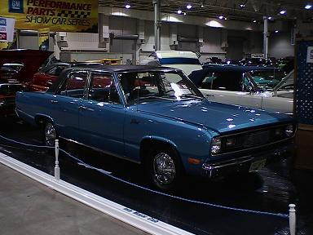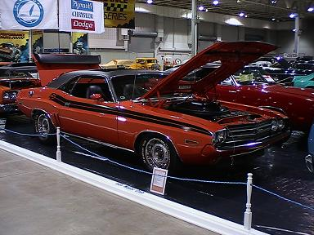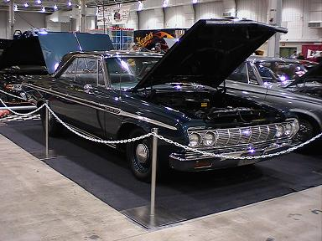

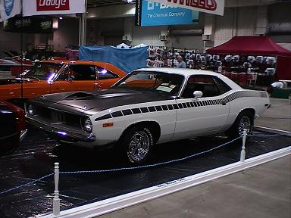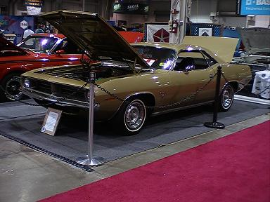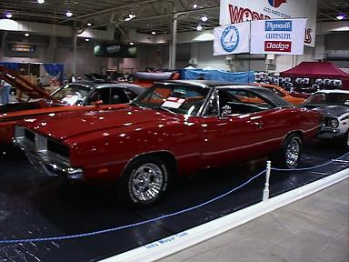

Trivia answer: Pete Hamilton drove the #40 Plymouth Superbird to victory in the 1970 Daytona 500 for car owner Richard Petty

We’d like to welcome new members:
Tim Baker, Avon – 70 Dodge Challenger R/T and a 70 Dodge Dart Swinger
Carlton & Regina Brock, Indianapolis – 68 Plymouth GTX
Michael & Patricia Harter, Merrillville – 70 Dodge Super Bee
Kimberly Hill, New Castle – 77 Chrysler New Yorker
Paul Jacobs, Evansville – 69 Dodge Charger and a 72 Plymouth Cuda
John Klir, Homewood, Il – 68 Plymouth GTX
Ken & Debbie Komlanc, Brownsburg – 68 Plymouth Road Runner
Jack Nitzel, Greenwood – 2005 Dodge SRT10
Jim Schaefer, Steger, IL – 70 Plymouth Duster 340 and a 71 Dodge D100 P/U
Troy & Jenny Sissom, Greenwood – 69 Dodge Dart
Josh & Gerry Slavin, Ambia – 69 Plymouth GTX and a 48 Anglia w/392 Hemi
Tim Stultz, Sheridan – 69 Dodge Coronet Super Bee.
David Tays, Greensburg – 70 Plymouth Road Runner
Shannon Tompkins, New Castle (no car listed)
Darren & Diane Turpen, Indianapolis – 71 Plymouth Road Runner
Raymond & Suzanne Vansickle, Lebanon – 70 Dodge Challenger T/A
We hope to see all of you soon at a meeting or event.
<><><><><><><><><><><><><><><><><><>

INDY MOPAR CLUB Monthly Meeting February 22, 2007 7:00 PM
Secretary’s Report
Welcome and sign in – John Bauer, President:
John brought the meeting to order. Asked if all had signed in on the attendance sheet. Then asked everyone to introduce themselves and tell a little about their cars and anything else pertinent. Dues are due, if anyone needs to pay tonight please see Mike Leyes, Treasurer. A reminder that Palmer Dodge is an Associate Member.

Treasurer’s Report/Membership Update – Mike Leyes:
Mike gave the treasurers report as of February 22, 2007. Beginning balance for February was $2,376.55; income was $2,706.55 (includes a deposit of $1,896.55 which closed out Key Bank and was deposited in the new Citizens State Bank account); Expenses were $3,746.79 (includes $1896.55 to close Key Bank), newsletter and postage expense, Indy Cylinder Head Swap Space, Member shirts for 2007, flyer copies, and $500.00 to Juvenile Diabetes Research. Ending balance is $1,336.31.

Event Calendar – Dan Kelly:
Dan talked about upcoming events for the year (see the calendar further in the newsletter.) Pat McKarski is posting Indy Mopar car shows with Indy Auto & R.V. and Old Cars Only, and Mopar Muscle. See John Bauer for $5.00 tickets to The IRP Family Day / National Points Meet, April 14th.

Communications Report – Dave Watt:
Dave reported that he has updated the IMC web-site with new background and pictures. He also told of the World of Wheels Awards.

Old Business – John Bauer:
- Club Member Profile for Newsletter & Website: March – Frank Goodrum; April – Mark Smith; May – Mike & Chris Rigney.
- John passed around the medal awarded to the Indy Mopar Club for outstanding support of the Juvenile Diabetic Research Foundation. (It was beautiful.)
- Palmer Show, May 5th. Door Prizes: John Bauer, Pat McKarski & Bob Biesel
- Fletcher Show, July 7th. Door Prizes: Steve Wisdom, Rick & Ginger Zimmerman
- Danville Show, September 22nd. Door Prizes: Mark Smith & Pat McKarski
- March Swap Meet, March 3rd & 4th. Discussion for workers schedule followed for both manning the booth and for the Reaction Time Racing Volunteers.

New Business – John Bauer:
- Pat McKarski brought up the idea of membership cards. It would help when asking for door prizes if they could show something from the club.
- Dan Kelly volunteered make up membership cards.
- March 3rd & 4th Swap Meet – Our workers to sell previous t-shirts.
- Ken Mosier wants to furnish a Finer Detail Award again. $100 per show, plus plaque. No previous winners per club.
- Pat McKarski told about a company that makes the signs for cars, www.carartsigns.com in Beech Grove
- Jan Peel told about our normal waitress, Donna, having an accident at work and will be off work for awhile, and will send card in IMC name. Sue Mayes suggested we take up a donation for Donna to go with the card.
The meeting was then adjourned.
Respectfully submitted – Chris Rigney, Secretary
<><><><><><><><><><><><><><><><><><>

Thanks to all the volunteers at the 12th Annual Chrysler Performance Trade Show March 3rd and 4th hosted by Indy Cylinder Heads. Volunteers were John Bauer, Dan Kelly, Dave Watt, Mike Leyes, Ed Leyes, Jim Kelly, Rick & Ginger Zimmerman, Stan & Jan Peel, Mark Smith, Bob Schonegg, Rick Eilert, Ken Scobel, Steve Wisdom, Sue Mayes, Ronda Cherry, Jim Parker, Chris Usher, Pat McKarski, Jim Kelly. This takes a lot of work to set-up, maintain, and tear down and pack up and haul home all the items that it takes to make a successful showing for our club.

A special thanks to Brian Schemenaur, Mike Leyes, Jim Kelly and Bob Schonegg for bringing their car out and putting them on display.

If anyone was not mentioned it was strictly unintentional.

Attending the February meeting were: John & Carol Ann Bauer, Bob Beisel, Dick Binger, Ronda & Dennis Cherry, Rick Eilert, Dan Kelly, Jim Kelly, Rick Kelly, Ed Leyes, Mike Leyes, Susan Mayes, Pat & Pat McKarski, Stan & Jan Peel, Mike & Chris Rigney, Bob Schonegg, Ken & Sharon Scobel, Bob Thomas, Dave Watt, Steve Wisdom, and Ginger Zimmerman.

April birthdays: Ken Lazzeri, 4-1; Bob Biesel, 4-2; Diane Gillock, 4-4; Tim Baker, 4-5; Ron Fedoryk, 4-10; Ginger Zimmerman, 4-14; Rick Eilert, 4-15; Stan Sanders, 4-17; Rick Zimmerman, 4-19; Jeff Culpepper, 4-21; Stan Peel, 4-27; Verne Williams, 4-27. April Anniversaries: Troy & Jenny Sissom, 4-18 (21 years). Congratulations to all!

Current Note: We have received a very nice Thank You Card from our waitress at Ryans, Donna, thanking us for our kindness and the donation. The card will be passed around at our March meeting.
<><><><><><><><><><><><><><><><><><>
Tattler’s Corner
All those people that tested themselves on the IMC Drag Racing Reaction Time game were really interesting to watch. Know who were the quickest for the most part? The kids!!! What does that tell you? On the new Seat Belt Law on the last page shouldn’t the driver and passenger be reversed?
<><><><><><><><><><><><><><><><><><>

UPCOMING EVENTS
**March 29, 2007, Thursday. 7 PM Indy Mopar Meeting at Ryan’s Steakhouse, US 31 South in Greenwood

**April 14, 2007, Saturday, IRP Family Day/Natl Points Meet, O’Reilly Raceway Park on US 136

**April 15, 2007, Sunday, 25th Annual Northern Illinois Region WPC Car Show and Swap Meet, Larry Roesch Chrysler/Dodge/Jeep, 200-260 W Grand Ave., Elmhurst IL. Rain or shine. For more info contact Steve Kelly, 9N852 Bowes Bend Dr, Elgin IL 60124-8365 or skelly48@comcast.net or 847-464-1301 until 9PM CST.

**April 26, Thursday. 7 PM Indy Mopar Meeting at Ryan’s Steakhouse, US 31 South in Greenwood

**May 5, 2007, 9-3 PM, The Indy Mopar Club will host an all Mopar car show at Palmer Dodge North at 4545 East 96th Street, Indianapolis, (317)-846-5555. Top 20 awards, door prizes, 50/50 drawing, Drag Racing simulator, DJ, food, and more. Rain date is May 12, 2007.

**May 18-20, Chrysler Classic at National Trails Raceway, Columbus, Ohio

**May 18-19, Hoosier Auto Show & Swap Meet at Marion County Fairgrounds, Indianapolis

**May 24, Thursday. 7 PM Indy Mopar Meeting at Ryan’s Steakhouse, US 31 South in Greenwood

**June 14-16, 2007, Tulsa Region Plymouth Owners Club, Tulsa, OK, featuring the Exhumation and
Unveiling of the 1957 Plymouth Time Capsule. .

**June 16, Saturday, 19th Annual Hog Jog Cruise-in & Car Show in Flora, Indiana

**June 24, Sunday, 9th Annual Wanamaker Old Settler’s Day Classic Car Show, Wanamaker. For more info call Stephanie at 317-862-9352 or sschemenaur14@sbcglobal.net

**July 7, 2007, 9-3pm, the Indy Mopar Club will host an all Mopar car show at Fletcher Chrysler Dodge Jeep at 3099 North Morton (US31) in Franklin Indiana, (317)-738-1470. Top 20 awards, door prizes, 50/50 drawing, Drag Racing simulator, DJ, food and more. Rain date to be determined.

**July 14, Saturday, “Rollin Back the 70’s Car Show and Carnival, Mike Aulby’s Arrowhead Bowl, 2331 Brothers Dr., Lafayette, IN. For more info call 765-427-8893 or www.arrowheadbowl.com

**July 17-21, 2007, WPC Club National Meet, Chicago, IL., hosted by Northern Il. Region in Lincolnshire, IL www.chryslerclub.org

**July 26, Thursday. 7 PM Indy Mopar Meeting at Ryan’s Steakhouse, US 31 South in Greenwood

**August 10-12, Mopar Nationals at National Trails Raceway, Columbus, Ohio

**August 18, 2007, Saturday, 2007 Cool Creek Park Jukebox Saturday Classic Car or Motorcycle Show, Westfield. Must be a pre-1982 car, truck, hotrod, custom or motorcycle. Call Michelle at 317-896-5874.

**August 30, Thursday. 7 PM Indy Mopar Meeting at Ryan’s Steakhouse, US 31 South in Greenwood

**September 19-23, 2007, North Carolina Region National Meet, Concord, NC. Watch for further info.

**September 22, 2007, 9-3pm, The Indy Mopar Club will host an all Mopar car show at Danville Chrysler Dodge Jeep located at 20 S. County Road 300 E. #362 in Danville Indiana, (317)-745-5809. Top 20 awards, door prizes, 50/50 drawing, Drag Racing simulator, DJ, food and more. Rain date is September 29, 2007.

**September 25, Thursday. 7 PM Indy Mopar Meeting at Ryan’s Steakhouse, US 31 South in Greenwood

**October 6-7, 2007, Newport Hill Climb, Newport, Indiana
<><><><><><><><><><><><><><><><><><>
Advertisements from our Web-site:
**For Sale: 66/ 67 B-body stuff i.e. wiring harnesses kick panels small chrome pieces. Robert at bkvorpe@sbcglobal.net or 317-753-8385
<><><><>
**For Sale: '78 Cordoba, light blue, 360/904. Reclining buckets, good glass, sell whole for $700 or part out. Located in west central Indiana. See pix at http://360.yahoo.com/gtx4spd Ric LaFollette cell # 317-372-8245 or Email gtx4spd@yahoo.com
<><><><>
**For Sale: N.O.S. front bra for '95 Stratus sedan, still in box, never taken out. Would fit other years, don't know which. $50.For sale: Carbon fiber hood with simulated scoop for '01 Stratus coupe, would fit other years, don't have interchange info. BRAND NEW, never installed, no holes drilled, never painted. $700. OBO.
**For Sale: '63 Plymouth factory shop manual, original, not repro. Very good condition. What's it worth? You tell me! Ric LaFollette 765 482-0985 or 317 372-8245 gtx4spd@yahoo.com
<><><><>
**For Sale: 1969 Plymouth GTX Recreation, triple black, 472 HEMI, 727 Torqueflite, Dana 60, red stripe tires and more. . . . $55,000 Verne Home (815) 935-0405 Cell (815) 216-0220 or gtxman@earthlink.net
<><><><>
**For Sale 1968 440 ENGINE - Less than 1,000 miles on build: .030 over with Ross 11.5 : 1 pistons; Eagle “H” rods; Steel Crankshaft; Milodon 8 quart oil pan; Indy Cylinder Head SR aluminum heads & valve covers; New Indy Cylinder Head roller rocker arms; Solid lift camshaft (No cam card); Mopar aluminum high rise intake manifold; Holley 950 double pump carb.; Fuel pressure regulator and plumbing. This is a VERY strong engine and is complete, less distributor. $6,000 John Bauer 317-769-3312 or 317-430-1265 email bauerconstruction@tds.net
<><><><>
**For Sale1979 Lil Red Express my dad bought new in Michigan and drove daily for 110,000 miles. Engine and transmission were freshened at 103,000 miles. I also have a TCI trans kit for 727, a 318 short block balanced W/Keith black pistons low mileage, A 904 and a 727 for small block and some head cores. I will deal on any of the items. I would make some one a great deal to come take it all!!!!!!!!!!!! Home765-325-9910. Cell 317-409-8422. Calls will be returned.
<><><><><><><><><><><><><><><><><><>
Fixing Stone Chips the Right Way
If you drive your classic regularly, sooner or later you are going to have a problem with stone chips. The first thing you have to do is clean out the chipped spot. If it is full of dirt or rust, the new paint won’t stick well, and the rust will continue to bubble away under there and lift even more paint. Eastwood sells a little rust brush that has a stiff fiberglass core that is perfect for getting out any rust and dirt. Just twist the brush around in the spot until you get to clean, bare metal, or, if the chip only goes down as far as primer, just clean it of dirt and contaminants.
Next make sure the area to be painted is clean of grease, oil, wax and silicone, because all of these will prevent the touch up paint from adhering properly. A good degreaser available from automotive paint stores will do the job, then wipe everything down carefully.
Now for the toughest part. The big challenge to fixing stone chips is finding matching paint if you don’t have any. More recent cars that still have their original factory finishes aren’t as big a problem because touch paint is usually available for them from dealerships or even parts stores. But when you have a custom-color repaint done on your car you should make sure the painter provides you with a little extra in a small can or bottle for touch-up later. Otherwise you’ll be stuck with having to remove a small item like a gas filler cover flap or ash tray and taking it to an automotive paint store to have the color matched, and that can get expensive.
Once you get the paint, just thin it a little so it will flow out nicely, they pour it into a paint pen if you have one. You could also use a small, camel hair brush or even cotton swabs for this boy, but a paint pen is more precise.
Daub the paint into the chip rather than dragging the pen along. You would do the same thing if you were using a brush or swab. You want the paint to build up, but not all in one coat. Next, let the paint dry while you work on other chips, and then come back and apply another coat, and another if necessary, until the paint bulges slightly above the surface of the surrounding finish when it dries.
You’re ready to finish the job. When you’ve done all the little bad spots, let the paint dry for several days so it is plenty hard, and then you can sand it flat with a little tool that looks like a fat dowel, or use an old spool and blue small disks of sand paper to it.. Use microfine 1500 grit sandpaper, dampen it and gently sand the area flat.
Work the spot down to the level of the surrounding paint, then buff the area out using polish and a small pad. There should be no bump or unevenness when you are finished sanding, but the paint will still be a little hazy. Use any fine polish to take out the slight scratches. A light touch is all that’s needed for this. After that, all you need to do is wax the area to restore the luster. If you work carefully and follow the steps, when you’re finished, you car will look as if it never got dinged at all.
<><><><><><><><><><><><><><><><><><>
A Little Bit of Humor
Nebraska Women – you have to respect them
Three men were sitting together bragging about how they had given their new wives duties. The first man had married a Woman from Iowa had told his wife that she was going to do dishes and house cleaning. It took a couple days, but on the third day he came home to a clean house and dishes washed and put away.
The second man had married a woman from Illinois. He had given his wife orders that she was to do all
the cleaning, dishes, and the cooking. The first day he didn't see any results, but the next day he saw it was better. By the third day, he saw his house was clean, the dishes were done, and there was a huge dinner on the table.
The third man had married a girl from Nebraska. He told her that her duties were to keep the house
cleaned, dishes washed, lawn mowed, laundry washed and hot meals on the table for every meal. He said the first day he didn't see anything, the second day he didn't see anything, but by the third day most of the swelling had gone down and he could see a little out of his left eye, enough to fix himself a bite to eat and load the dishwasher.
<><><><><><><><><><><><><><><><><><>
New Seat Belt Law
This is very Important, please pass on to friends and family. THIS MAY SAVE A LIFE!
The National Highway Safety Council has done extensive testing on a newly designed seat belt. Results show that accidents can be reduced by as much as 45% when the belt is properly installed. Correct installation is illustrated below.......
